The City School – Educational Technology Department

Aims+ User Manual

For Regional Guidance

Contents

Introduction 2

Advantages of Aims+ 2

Overview 3

Setup 4

Assign Student 4

Student Absent In Exam 5

TCS Reports 5

Non Academic Report 🡪 Non Academic Reports (CO) 5

Academic Report 🡪 Academic Reports (CO) 6

TCS Reports 🡪 A/O Level Reports 7

Results 8

Result Card 8

Search 8

Help Desk 9

Help Desk 🡪View Complaint Box 9

Archive Reports 10

Archive 🡪 Archive Reports 10

# Introduction

AIMS+ is an advanced version of idealAims to manage student data. Academic Student Information Systems (Aims+) provide capabilities for entering student test and other assessment scores, build student schedules, track student attendance, and manage many other student-related data needs in a school.

## Advantages of Aims+

* Aims+ Management System turns your manual means of results into digital form over an online hosting platform.
* Archives your school results from the very date you start using it.
* Automatically computes cumulative scores and grades according to figures being keyed in.
* Helps you to call-up a particular student’s result at any point in time.
* Rates your school higher than your competitors.
* Reduces the rate of human errors. E.g. Mis-calculation of cumulative scores.
* Automatically awards remarks to student based on grades.
* Parents and guardians can have access to their ward’s results/performance is school. This helps to put such a student in check.

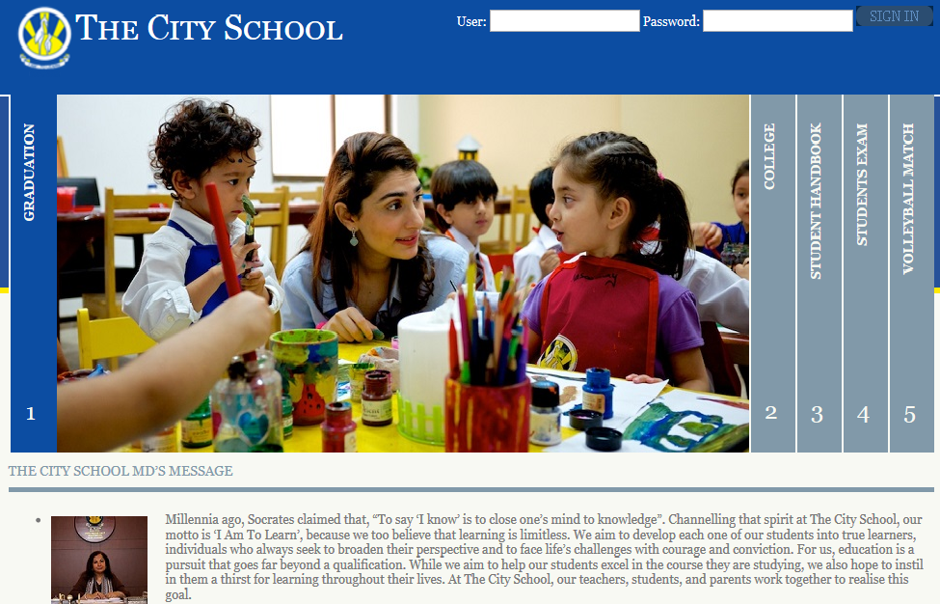

# Overview

1. Setup
2. Reports
3. Result
4. Search
5. Helpdesk

These main menus contain sub menus to facilitate the Regional Officer.

1. Setup

Setup menu contains three sub menus

* Assign Student

(Assign student of a class to a section)

* Student Absent In Exam
* (Student Absent In Exam)

1. Reports

There are two types of reports

* Non Academic Report
* Academic Report
* A/O Level Reports

1. Result

* Result Card

(View result card of a student)

1. Search

Regional Officer can search records using following search options

* Search Student
* Search User
* Search Class
* Search Section
* Search Subject

1. Helpdesk

Regional officer can use Helpdesk have following option

* View Complaint Box

1. Archive

Regional officer can generate Archive reports have following option

Archive reports

# Setup

## Assign Student

Setup 🡪 Assign Student

1. Click on the **Setup** and then click **Assign Student**.
2. Here campus officer can assign/un-assign students of a class to section.

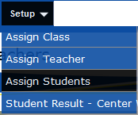

Select Status (Approved/Un assigned and assigned) 🡪 Class available🡪section

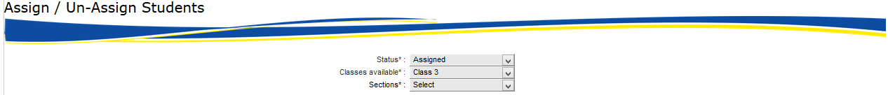

Student’s information will appear in below form

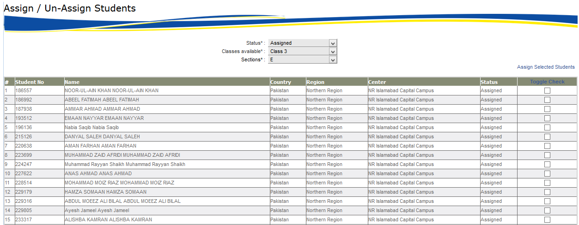

Select checkboxes of desired students and click on **Assign Selected Students** button, a small screen will appear below.

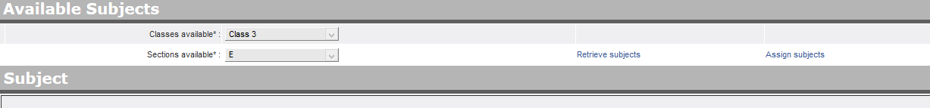

## Student Absent In Exam

Setup 🡪 Student Absent In Exam

This screen shows the result of student

Regional officer will select

Find the relevant Student on Clicking on Find Student then after selecting Term the desired screen will show information

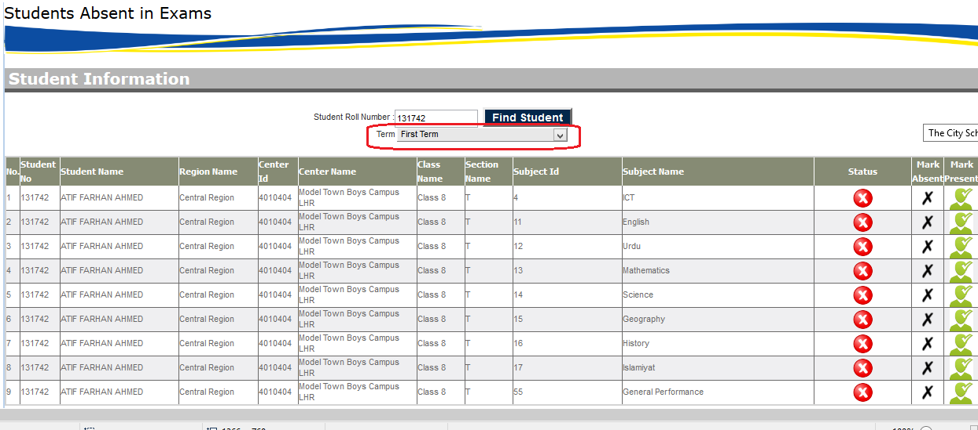

Now regional officer can mark the attendance of desired Student

# TCS Reports

## Non Academic Report 🡪 Non Academic Reports (CO)

TCS Reports 🡪 Non Academic Reports 🡪Non Academic Reports (CO)

1. Click on the **TCS Reports 🡪 Non Academic Reports** and then click **Non Academic Reports (CO)**.
2. In this section campus officer can view all non-academic reports.

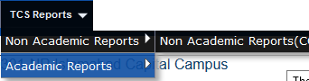

Regional officer will select

Main Organization🡪Main Organization Country🡪Region🡪Center🡪Session🡪Class and Section

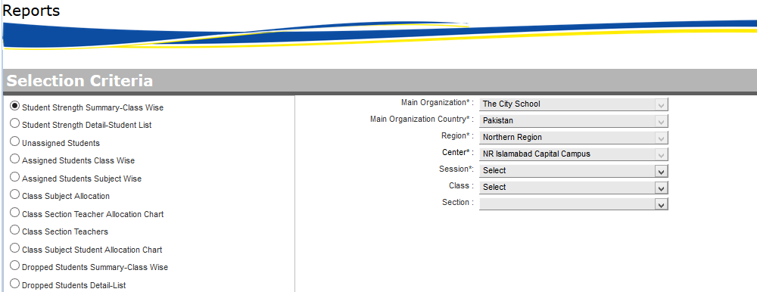

This Screen have following reports

* Student Strength Summary – Class Wise
* Student Strength detail – Student List
* Unassigned Students
* Assigned Students Class Wise
* Assigned Students Subject Wise
* Class Subject Allocation
* Class section Teacher Allocation Chart
* Class Section Teacher
* Class Subject Students Allocation Chart
* Dropped Student Summary – Class Wise
* Dropped Student Detail—list

## Academic Report 🡪 Academic Reports (CO)

(View Academic Reports Center Wise)

TCS Reports 🡪 Academic Reports 🡪 Academic Reports (CO)

1. Click on the **TCS Reports 🡪 Academic Reports** and then click **Academic Reports (CO)**.
2. In this section campus officer can view all academic reports.

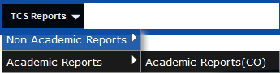

Regional officer will select

Main Organization🡪Main Organization Country🡪Region🡪Center🡪Session🡪Class 🡪 Section and Subject

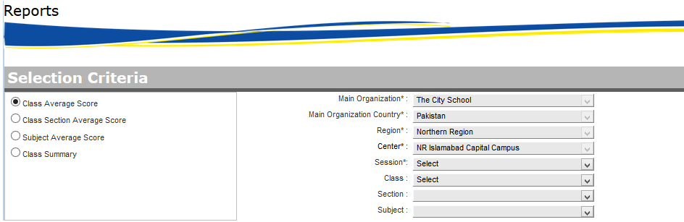

This Screen have following reports

* Class Average Score
* Class section Average Score
* Subject Average Score
* Class Summary

## TCS Reports 🡪 A/O Level Reports

TCS Reports 🡪 A/O Level Reports

1. Click on the **TCS Reports 🡪 A/O Level Reports**
2. In this section campus officer can view all academic reports.

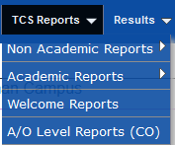

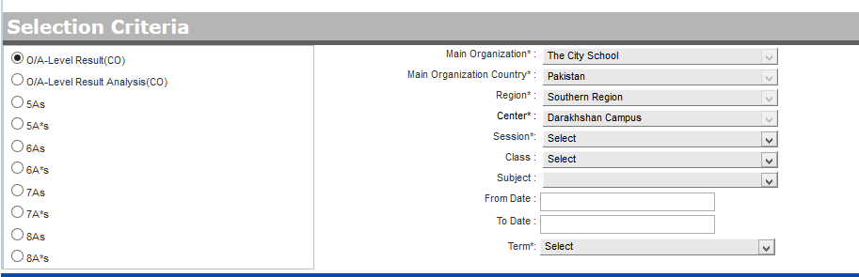

# Results

## Result Card

Results 🡪 Result Card

1. Click on the **Results 🡪 Result Card**
2. In this section Regional officer can Results.



Select Main Organization🡪Main Organization Country🡪Region🡪Center🡪Session🡪Class 🡪 Section 🡪 Subject and Term

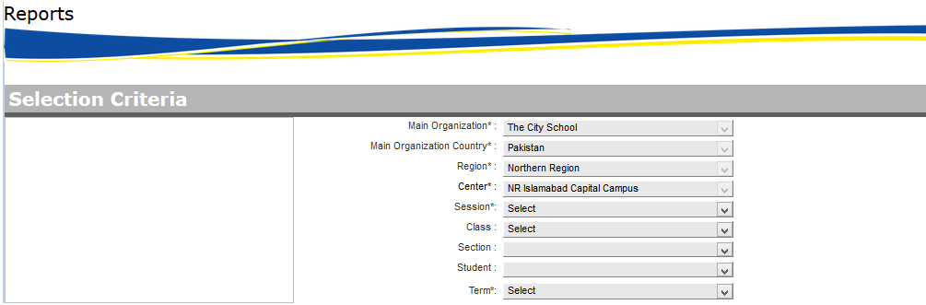

# Search

This system provide facility to search criteria for users and have following categories

**Search** 🡪 **Search Student**

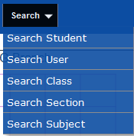

* Search Student
* Search User
* Search Class
* Search Section
* Search Subjects

Campus officer can search his desired information by given screen. These screens contains some filters like

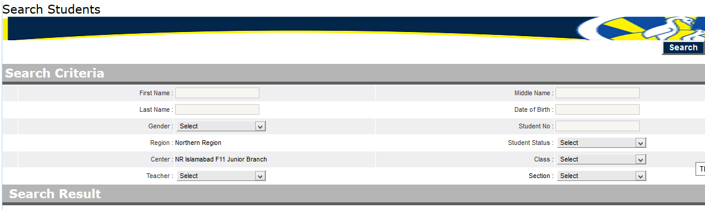

And desired result shown in grid form

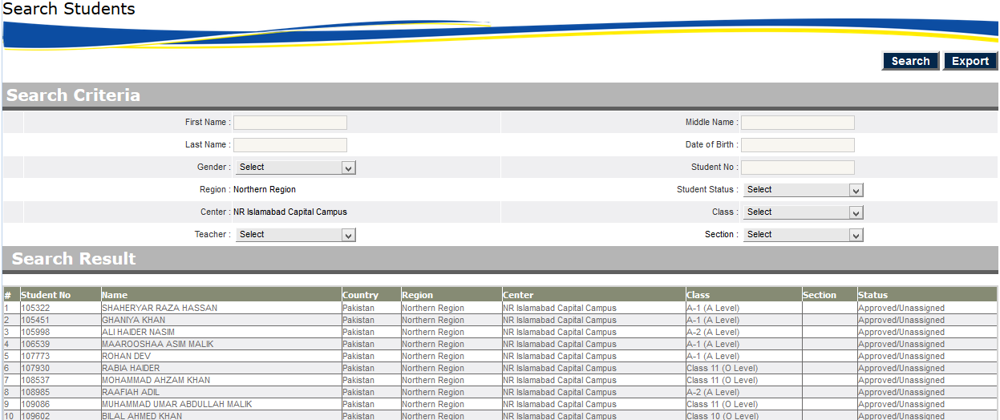

# Help Desk

## Help Desk 🡪View Complaint Box

Help Desk 🡪 Complaint Box

1. Click on the **Help Desk 🡪 View Complaint Box**
2. In this section campus officer can use complaint box



Regional officer can check the status of requests of relevant issues.

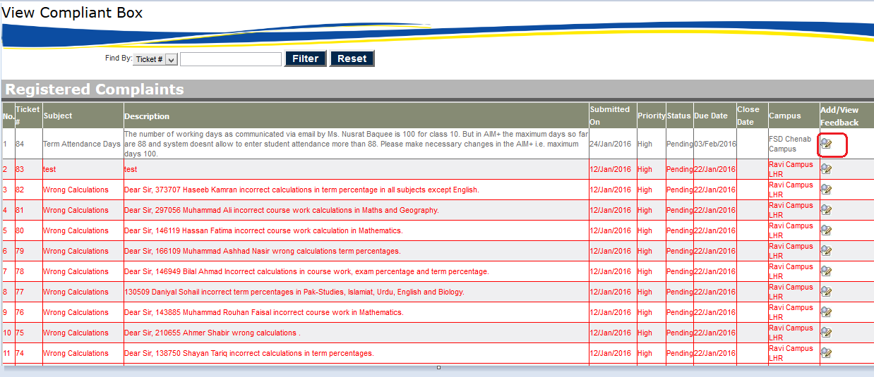

Regional office can add / View feedback on clicking Red Highlighted button.

# Archive Reports

## Archive 🡪 Archive Reports

Archive🡪 Archive Reports

1. Click on the **Archive 🡪 Archive Reports**

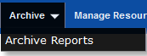

Campus officer will select

Main Organization🡪Main Organization Country🡪Region🡪Center🡪Session🡪Term

And have following reports

